**1. Initial Setup**

* Confirm understanding of project objectives:
  + Analyze user behavior and performance of financial services.
  + Focus on cohorts based on the month of their first cash advance.
* Gather required data from Ironhack Payments.
* Review the data-sharing protocols and permissions.

**2. Data Quality and Preprocessing**

* Conduct a **Data Quality Analysis**:
  + Check for missing values, inconsistencies, and duplicates.
  + Document data quality issues and the steps to resolve them.
* Clean the dataset:
  + Remove or address inconsistencies.
  + Handle missing values appropriately.
  + Verify accuracy of date fields and transaction values.
* Create derived columns for cohort analysis:
  + First cash advance month.
  + Service usage frequency metrics.
* Ensure data format is compatible with analysis tools (e.g., Python, Tableau).

**3. Exploratory Data Analysis (EDA)**

* Perform descriptive statistics on key metrics (e.g., usage frequency, revenue).
* Visualize data:
  + Monthly trends for each cohort.
  + Distribution of incident rates.
  + Revenue patterns over time.
* Identify outliers and trends that need further exploration.
* Document findings in an EDA report, including key patterns and any hypotheses.

**4. Cohort Analysis Execution**

* Define cohorts by their first cash advance month.
* Calculate:
  + **Frequency of Service Usage**: Monthly activity rates per cohort.
  + **Incident Rates**: Variability in payment incidents.
  + **Cohort Revenue**: Total revenue generated per cohort over months.
  + **Proposed New Metric**: Brainstorm, implement, and calculate (e.g., customer retention rates or average revenue per user).
* Visualize metrics over time for each cohort:
  + Line charts or heatmaps for service usage trends.
  + Revenue graphs by cohort.

**5. Reporting and Presentation**

* Prepare the following deliverables:
  + **Python Code**: Ensure it includes data loading, cleaning, cohort creation, metric calculation, and visualization.
  + **Tableau Dashboard**: Interactive views for the Ironhack Payments team.
  + **EDA Report**: Include visualizations and insights.
  + **Data Quality Report**: Document identified issues and resolutions.
  + **Presentation Slides** (maximum 4 slides):
    - Key findings and insights from cohort analysis.
    - Recommendations based on the findings.

**6. Review and Iteration**

* Share findings and visualizations with stakeholders for feedback.
* Iterate on analysis or visualizations based on feedback.

**7. Bonus (Optional Enhancements)**

* Create a **Streamlit App** for dynamic data interaction.
* Implement an operationalized .py script:
  + Include clear documentation and execution instructions.
  + Test script functionality in a terminal environment.
* Convert code to use an alternate strategy (e.g., object-oriented if the current is functional, or vice versa).

**8. Submission and Handover**

* Verify all deliverables are completed and uploaded.
* Prepare final documentation for the Ironhack Payments team.

EDA Notes.

Cash-request

================ DATA INFO ================

<class 'pandas.core.frame.DataFrame'>

RangeIndex: 23970 entries, 0 to 23969

Data columns (total 16 columns):

|  |  |  |  |  |
| --- | --- | --- | --- | --- |
| **Column** | **Non-Null Count** | **Dtype** | **Missing Count** | **Missing %** |
| id | 23,970 | int64 | - | 0 |
| amount | 23,970 | float64 | - | 0 |
| status | 23,970 | object | - | 0 |
| created_at | 23,970 | object | - | 0 |
| updated_at | 23,970 | object | - | 0 |
| user_id | 21,867 | float64 | 2,103 | 8.8 |
| moderated_at | 16,035 | object | 7,935 | 33.1 |
| deleted_account_id | 2,104 | float64 | 21,866 | 91.2 |
| reimbursement_date | 23,970 | object | - | 0.0 |
| cash_request_received_date | 16,289 | object | 7,681 | 32.0 |
| money_back_date | 16,543 | object | 7,427 | 31.0 |
| transfer_type | 23,970 | object | - | 0.0 |
| send_at | 16,641 | object | 7,329 | 30.6 |
| recovery_status | 3,330 | object | 20,640 | 86.1 |
| reco_creation | 3,330 | object | 20,640 | 86.1 |
| reco_last_update | 3,330 | object | 20,640 | 86.1 |

================ DUPLICATE ROWS ================

Total duplicate rows: 0

================ COLUMN STATISTICS ================

|  |  |  |  |  |
| --- | --- | --- | --- | --- |
| **Metric** | **id** | **amount** | **user_id** | **deleted_account_id** |
| **Count** | 23970 | 23970 | 21867 | 2104 |
| **Mean** | 13910.966 | 82.721 | 32581.251 | 9658.755 |
| **Std. Dev.** | 7788.117 | 26.528 | 27618.566 | 7972.743 |
| **Min** | 3 | 1 | 34 | 91 |
| **25th Percentile (Q1)** | 7427.25 | 50 | 10804 | 3767 |
| **Median (Q2)** | 14270.5 | 100 | 23773 | 6121.5 |
| **75th Percentile (Q3)** | 20607.75 | 100 | 46965 | 16345 |
| **Max** | 27010 | 200 | 103719 | 30445 |

|  |  |  |
| --- | --- | --- |
| **Column** | **Skewness** | **Kurtosis** |
| **id** | -0.11 | -1.16 |
| **amount** | -0.92 | -0.22 |
| **user_id** | 0.94 | -0.22 |
| **deleted_account_id** | 0.86 | -0.68 |

Categorical Summary:

|  |  |
| --- | --- |
| **Status Category** | **Count** |
| **money_back** | 16397 |
| **rejected** | 6568 |
| **direct_debit_rejected** | 831 |
| **active** | 59 |
| **transaction_declined** | 48 |
| **direct_debit_sent** | 34 |
| **canceled** | 33 |

* + Missing column ‘reason’ in cash request file.
  + Date format **ISO 8601**

### ****Structure of the Format****

1. **Date**: YYYY-MM-DD (e.g., 2019-12-10)
   * YYYY: Year
   * MM: Month
   * DD: Day
2. **Time**: hh:mm:ss.sssssss+zz:zz
   * hh: Hours (24-hour format)
   * mm: Minutes
   * ss.sssssss: Seconds (with microseconds or milliseconds precision)
   * +zz:zz: Timezone offset from UTC (e.g., +00:00 means UTC)

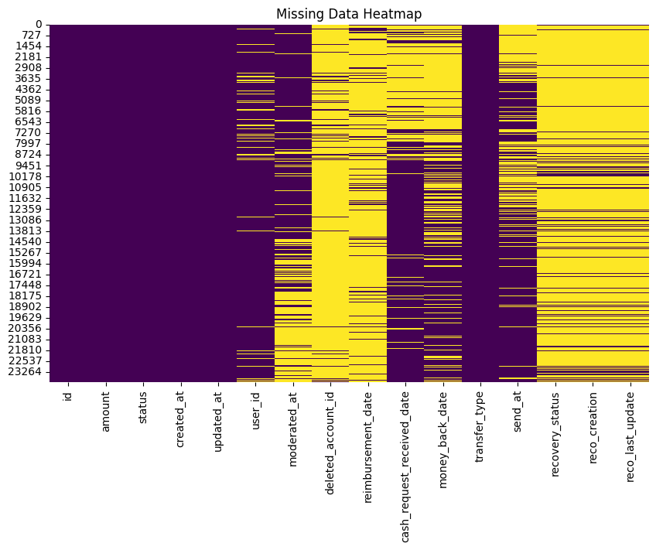

**user_id, reimbursement_date, deleted_account_id have significant missing data**

id and amount are almost entirely complete

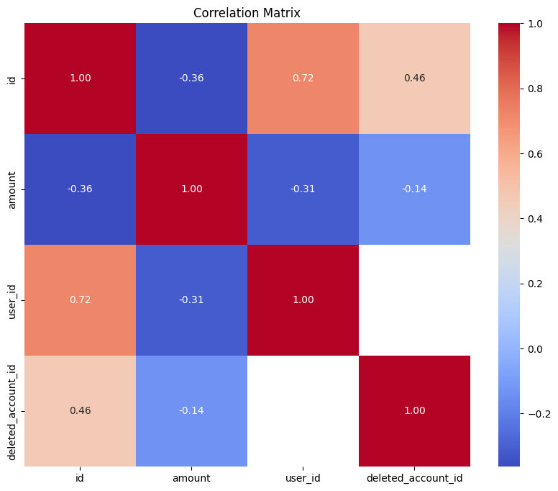

**id and user_id**:

* Correlation = **0.72**: A strong positive correlation, suggesting that the id and user_id are likely related or follow a sequential pattern.

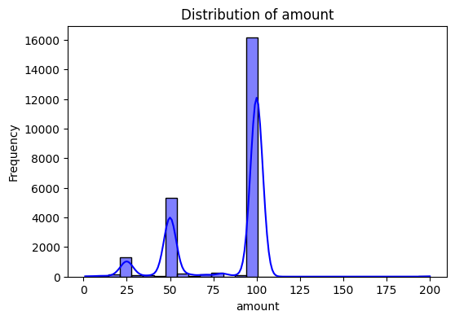

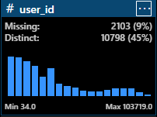

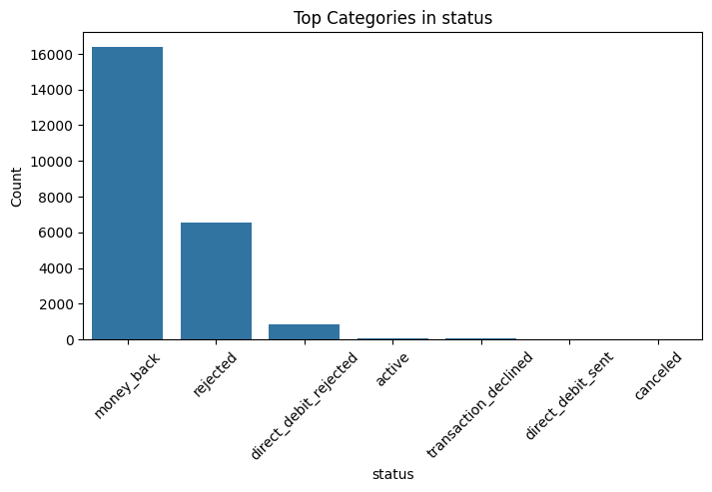

Cohorts

